**LIBRARY MANAGEMENT SYSTEM**

**CS-218 DATA STRUCTURES AND ALGORITHM**

**OPEN ENDED LAB**



**SUBMITTED BY**

**CS-20015**

**SYED MUHAMMAD**

**SUBMITTED TO**

**IBSHAR ISHRAT**

**DEPARTMENT OF COMPUTER AND INFORMATION SYSTEMS** **ENGINEERING**

# LIBRARY MANAGEMENT SYSTEM: -

The attached library management system is developed using Python programming language. It is easy-to-use and is designed to use command line interface. It can perform a number of operations on the data stored in the library records which enables the admin to have a complete command over the data.

On running the program the user is displayed with a simple user-friendly main menu. The menu includes the list of books currently in the library and different functions offered by the program. It can be easily operated by anyone with a basic understanding about operating a computer.

Attached with this report is the program (Python script) main.py .

# CLASSES USED IN THE PROGRAM: -

Following are the classes used in developing this program:

* Data Structures
* Library
* Admin Portal
* Student Portal

# DATA STORED IN CSV FILES :-

1. Books record
2. Borrow record (Separate file for every student)
3. Student Record

# BRIEF DESCRIPTION OF THE SOFTWARE: -

* 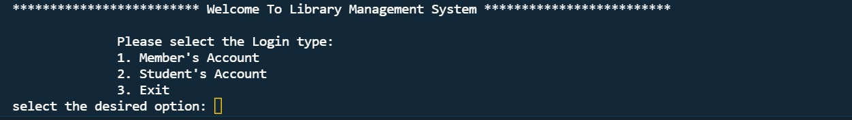Upon running the software, a login screen is shown with three options, member login, student login and exit.
* 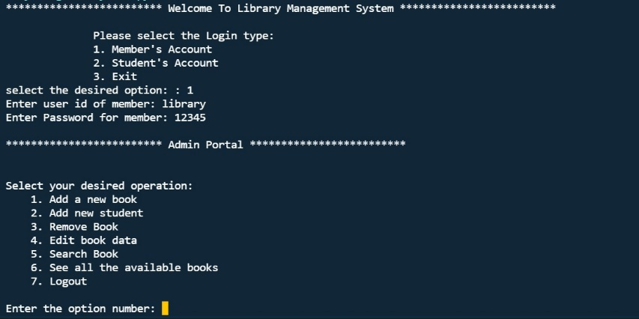Member’s account is for the library staff use and has a fixed user ID and password automatically generated. The admin can add and remove a book, add/remove student accounts, search books and some more features.

**Member Account Info:**

Username: library

Password: 12345

* The student’s account is setup by the admin and the students can access all available books, borrow a book, check borrowed books, renew a book, reserve a book and return a book.

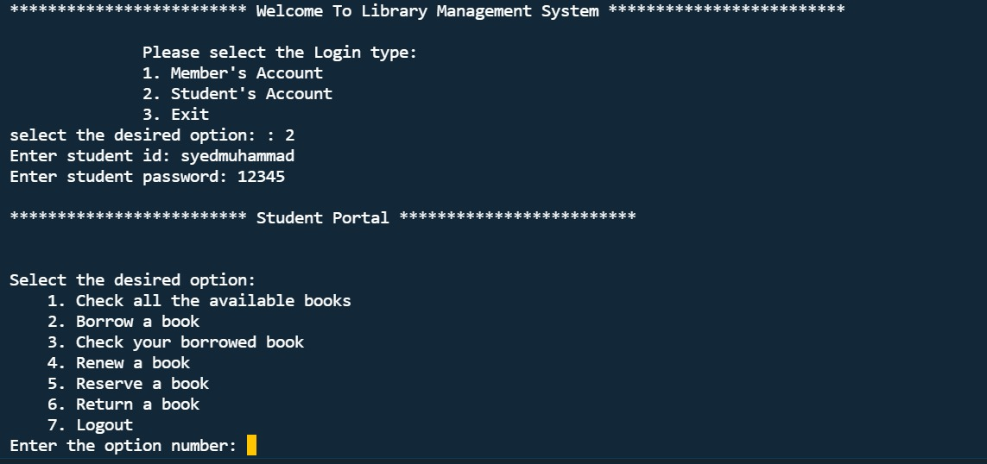

**Sample Student Account Info:**

Username: syedmuhammad

Password: 12345

# FEATURES OF LIBRARY MANAGEMENT SYSTEM: -

Some features of the supermarket inventory database are as follows:

* A simple and straightforward user interactive main menu.
* Provides the facility to overwrite an existing book information and create a new one in the same file.
* User can be Admin of the library or a student where a student account can only be made by a library member.
* One slight hurdle is that the user have to manually make sure that the entered student id for every student added to the database must be unique.
* I have used **MERGE SORT** as the sorting algorithm to sort the books data entered.
* I have used **BINARY SEARCH** algorithm to search the book in the library.
* Students’ data is saved in a well-organized manner in a CSV file with a student’s username (unique for every student), name, password.
* Books are saved with their title, author, genre and publication date.
* A very efficient feature is ‘Search’. The user can search by Book id of the book.
* Another highlighting feature is that a student can reserve a book for himself/herself.
* The software also keeps track of the books borrowed by students.
* Books can be borrowed for a period of 1 week, the borrow time period can be renewed anytime for an extension of 1 week and updated accordingly depending upon the returning day of the book.

# REFERENCE :-

▪ Lectures